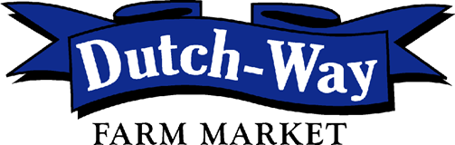

Now Hiring!

Dutch Way has a full-time position in our Maintenance Department. This position is for general maintenance with a focus on refrigeration and HVAC. We are willing to train for this position.

If interested in full-time employment upon graduating please contact Sherrie Bernard at 717-949-3400 or complete an application at
Dutchwayfarmmarket.com

