LEBANON COUNTY
CAREER TECHNOLOGY CENTER
NEW TEACHER ORIENTATION
INDUCTION PROGRAM HANDBOOK
2022-2023

Contents
TABLE OF CONTENTS 2
INTRODUCTION AND PURPOSE 5
ROLES AND RESPONSIBILITIES 5
SENDING SCHOOLS 6
STAFF HANDBOOK 6
TIME SCHEDULES 6
COLLECTIVE BARGAINING AGREEMENT AND POLICY 6
STAFF ABSENCES 7
ABSENCE REPORTING 7
ABSENCE CALL-OFF PROCEDURE 7
EMERGENCY OPERATIONS PLAN 7
STUDENT INFORMATION SYSTEM 7
Learning Management System 7
STUDENT ATTENDANCE PROCEDURES 8
SPECIALLY DESIGNED INSTRUCTION INFORMATION 8
SOURCES OF SUPPORT 8
FORMS 11
LESSON PLANS 11
CURRICULUM 11
APPENDIX 13

INTRODUCTION AND PURPOSE
The Lebanon County Career and Technology Center's New Teacher Orientation and Induction Program is designed to encourage and coach new teachers through their first two years of service. Research proves that what a teacher knows and can do is often the determining factor in student performance. We passionately believe in the quality assurance that comes from a cohesive, collaborative approach to the professional development of new hires. As such, the goals of the LCCTC's New Teacher Orientation and Induction Program are to build a network of support and community for incoming staff members and to articulate the school's philosophy of quality teaching and learning. We believe it is our responsibility to continually grow in the profession so that students have the best possible opportunity for success.
The program relies on teamwork among teachers, mentors, and building administrators. The essential components of the program include the support of a one-to-one mentor, participation in a series of training workshops, and regular meetings with building administrators. The workshop sessions are designed to provide essential skills and knowledge so that new teachers are well-equipped for success. The topics are detailed on page 5.
We believe in high quality career and technical education and our teaching staff is our best resource for student success. Therefore, the New Teacher Induction and Orientation Program requires the participation of all certificated employees regardless of previous experience or whether they have completed a similar series through another school. All teachers must complete the induction program to receive their level Il certificate. The Administration may waive portions of the program for experienced teachers new to LCCTC (Lebanon County Career and Technology Center) who have previously completed an induction program. Teachers will complete a New Teacher Orientation and Induction Program Log to document their experiences, reflect on their professional practice, and make recommendations for improvement.
It should also be noted that this manual is not intended to be all inclusive. You will need to rely upon your mentor and supervisor to direct you to other resources to function effectively in your new position at the LCCTC.

ROLES AND RESPONSIBILITIES
Mentor Teachers: See mentor handbook for more details.
- Assist the new teacher to identify and priorities their most immediate needs
- Help the new teacher with strategies to organize and manage the instructional program
- Help the new teacher to modify or develop curriculum to meet Chapter 4 and Chapter 339 requirements
- Help the new teacher to implement the strategic plan priorities relevant to his/her program
- Provide suggestions on instructional techniques, assessment, grading, and recordkeeping
- Help the new teacher with the content of the teacher handbook (S drive), policy manual student handbook (both on www.lcctc.edu), and teacher contract. (A hard copy may be obtained from the union representative.)
- Help the new teacher with suggestions on communicating with parents and staff (LMS, Emails via CSIU, phone logs, etc.)
- Help in obtaining resources — materials, equipment, repairs, maintenance, support services, forms and procedures
- Serve as a confidential mentor, reflective partner and a "sounding board"
- Meet with the new teacher a minimum of once a week for one hour and attend scheduled group meetings
- Complete all necessary forms, evaluations, and paperwork

Inductees
- Attend new teacher meetings as scheduled
- Meet with their mentor a minimum of once a week and complete the coach mentor activities checklist, as well as discuss any classroom management issues, grading questions, or other topics of concern as they come up.
- Attend, if possible, other approved workshops, seminars, and meetings as recommended by the Administration and Professional Education Committee

SENDING SCHOOLS
The Lebanon County Career and Technology Center (LCCTC) is a part time Area Vocational Technical School.
The LCCTC is sponsored by:
Annville-Cleona School District
Cornwall-Lebanon School District
Eastern Lebanon County School District
Lebanon School District
Northern Lebanon School District
Palmyra Area School District
The LCCTC also serves students attending nonpublic schools located in Lebanon County as well as adult students.

STAFF HANDBOOK
The Staff Handbook is published electronically.
S: Drive
Staff Handbook/Staff Handbook (current year)

TIME SCHEDULES
All full-time teachers serving secondary students are assigned to work 7:45 a.m. to 3:15 p.m. You are provided a 30 minute duty free lunch. You may have additional duties assigned before the student day, mid-day and after the student day. You are responsible to know your duties and fulfill them. Please note that your duties may change on a quarterly basis. You will find supervision assignments, a daily time schedule, and the school calendar in the Staff Handbook under Calendars & Schedules. If you are an Instructor of a full-day program, Lunch, English, and Math schedules are also found under Calendars & Schedules.

COLLECTIVE BARGAINING AGREEMENT AND POLICY
Professional employees are bound by the terms and conditions of the Collective Bargaining Agreement between the Lebanon County Career and Technology Center and the Lebanon County Career and Technology Center Education Association. For a copy of the Collective Bargaining Agreement, please see an Association Officer. Current officers include: Alicia Wike, President; Eric Tanger and Hanna Seyfert.
All LCCTC employees are also bound to the LCCTC Policy. All policies can be found in electronic format on the LCCTC Website ( www.lcctc.edu ) under Resource, Our Approach.

STAFF ABSENCES
The Collective Bargaining Agreement affords full-time teachers with sick days and Personal/Emergency Days. You receive ten (10) sick days per year. All unused sick days accrue.
Professional employees are granted three (3) days of personal leave per year, accruable to five (5) days. One (1) personal day may be used as emergency leave. Please see your Collective Bargaining Agreement for terms and conditions related to sick days and personal days.

ABSENCE REPORTING
All planned absences whether sick, personal, staff development or emergency must be submitted to the Administration prior to the absence on the Staff Absence Reporting form. These forms are available in the Main Office and the Business Office. Completed forms should be submitted to Assistant Director of Programs for approval. Time requirements for prior submission are found in CBA, Policies and/or Staff Handbook.
Unplanned absences whether sick or emergency also require the submission of a Staff Absence Reporting form on the day of your return to work.

ABSENCE CALL-OFF PROCEDURE
You must report an unplanned absence prior to the school day in a timely manner. All calls must be received by 6:30 a.m. at the latest. When making your call-off, you must state your reason for absence – either sick or emergency.

Please text Dawn Vanwinkle, Administrative Assistant, to report your absence. She is available until 9:30 p.m. or after 5:30 a.m. Dawn’s cell phone number is 717-224-1320. Please contact Dawn before 6:30 a.m. of the day you are requesting off.

EMERGENCY OPERATIONS PLAN
Maintaining a safe and secure environment is highly valued at the LCCTC. One vital component of maintaining a safe and secure environment is the Emergency Operations Plan. All staff members must have full knowledge of this plan, which is available on the staff server. Do not delay in familiarizing yourself with this plan. An emergency guidelines booklet is also available in all classrooms. The Assistant Director of Students will review this during induction meetings.

STUDENT INFORMATION SYSTEM
LCCTC uses CSIU as our student information system (SIS). This system is used to: record grades, take attendance, find student data, report student discipline issues, keep records of parent contacts. Your mentor teacher is your resource for taking attendance, entering grades and discipline reporting procedures. Mrs. Flowers (School Counselor) is also a CSIU resource. Additional resources are location in Schoology.com-Coach’s Corner-Resources-Grading Resources folder. Administrators can assist you with discipline reporting if needed.

Learning Management System
Schoology is our online learning management system. This system allows you to provide materials and instruction in an online learning format, communicate with students, provide feedback and interface with other online tools, such as videos, electronic testing tools, post a calendar of events and assignments, as well as course updates and more. The LMS does not replace, but supplements, classroom instruction. The Instructional Coach, Network Administrator, and your mentor will support you in learning to use and navigate this system. You will also be added to a resource group in Schoology called Coach’s Corner and the New Teacher Induction Course.

STUDENT ATTENDANCE PROCEDURES
Take attendance within 10 minutes of the session start time by logging into CSIU and using the procedures contained in the following link:
Login to CSIU: https://sis.csiu-technology.org/Login.aspx?ReturnUrl=%2f
CSIU Beginners Webinar: https://help.csiu.org/portal/en/kb/articles/sis-teacher-connect-for-beginners-webinar-5-10-2021 (You must be logged into CSIU. This can be accessed by clicking on the question mark at the top right corner.)

SPECIALLY DESIGNED INSTRUCTION INFORMATION
Specially Designed Instruction (SDI) are instructional modifications for individual students based on their disability and needs. The SDI are developed by the IEP or 504 Teams. Once established in the IEP, they become a legal obligation, protected by federal law. Teachers are expected to know and implement SDI found in student IEPs and accommodations specified in 504 Plans. IEP information can be accessed by clicking on the purple dot beside a student's name in the CSIU system. 504 Plan information can be accessed by clicking on the green dot beside a student's name in the CSIU system.

SOURCES OF SUPPORT
The administrative team is available to assist you. While various administrators have specific responsibilities related to overall operations, please see any administrator with any questions. At the very least, they will direct you to the appropriate person to assist you.
The School Counselors and administrative assistants are also reliable sources of information and support, especially for social emotional health, grading, and career planning.
Special Populations: The Special Populations Program supports struggling learners within the CTC learning environment by attempting to reduce and remove barriers to learning. The Special Populations program strives to ensure equity for all students and advocate for students in need of assistance. Special populations aides in the acquisition of academic knowledge and technical employability skills of students who are identified in the subgroups of (Defined by the Carl D. Perkins Act):
Individuals…
1. with disabilities
2. from economically-disadvantaged families, including low-income youth and adults
3. preparing for non-traditional fields
4. single parents, including single pregnant women
5. who are English language learners
6. who are homeless
7. youth who are in, or have aged out of, the foster care system; and
8. youth with a parent on active duty in the armed forces

The department consists of a program coordinator, two learning facilitators, one bilingual aide, one instructional aide, and one part-time instructional aide. Each CTC program is assigned a learning facilitator to support students who qualify for any of the subgroups above. You will likely be working closely with this department. Feel free to approach them with questions or concerns. The Special Populations office is located in the main hallway between C wing and D wing.

The Business Office supports the overall operation of the LCCTC in many ways. You will interface with them most commonly on purchase requisitions, payroll, and benefits. This Office is in the main hallway between C wing and D wing.
Technology support is provided by Jason Nace, Network Administrator. His office is in the Warehouse (D Wing.)

Instructional Coaching: The Instructional Coach serves as a thought partner to support all teachers in planning and implementing instructional goals in the classroom. Breathe easy! All communication with the Instructional Coach is CONFIDENTIAL! The Instructional Coach IS NOT administrative and DOES NOT evaluate teachers. Some examples of instructional coach partnership may look like: co-planning, co-teaching, lesson feedback, student engagement support, instructional strategies, modeling strategies, classroom management and support in trying new things. The sky is the limit!

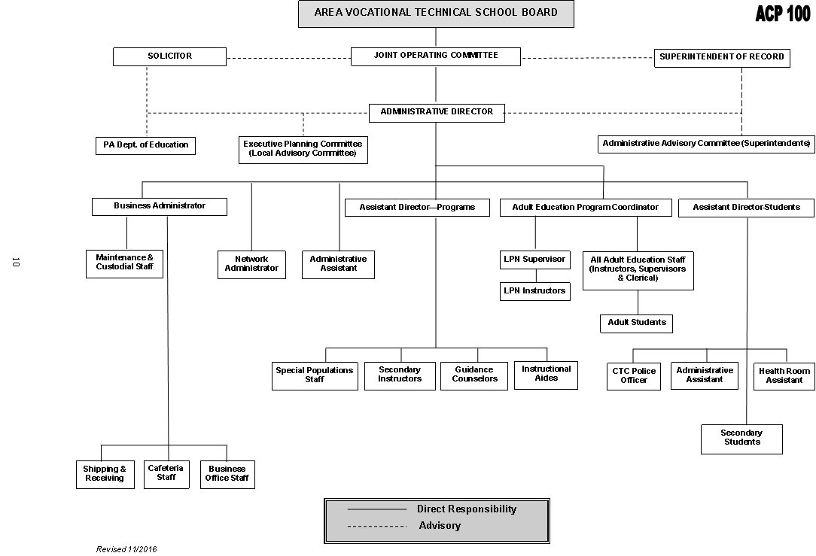

FORMS
Information relating to the most used forms is found in the list below. Your mentor and the Administrators can assist.

Director | - Purchase Requisitions  - Monthly Expense Forms  - Staff Absence Forms
Assistant Director of Programs | - Staff Absence Forms  - Comp. Guides  - Mileage Re-imbursement Forms  - Lesson Plans
Assistant Director of Students | - Shop Work Agreements  - Fieldtrip Forms  - Fundraisers  - Scholarship Forms  - Vehicle Use Form  - Volunteer Forms
Director’s Administrative Assistant | - Conference/Workshop Paperwork and Corresponding Absence Reporting Forms  *(Mailbox located in the main office: last row of wooden mailboxes)
School Nurse | - SAP Referral Forms  - Student Medical Profiles  - Emergency/Fire Drill Logs  - Staff Emergency Contact Forms  (Health Room Assistant mailbox)

LESSON PLANS
All teachers are required to submit lesson plans for the following week by the end of the school day on the last school day of the week. Assistant Director of Programs will provide instruction and assistance on completion and submission. The Instructional Coach can be accessed for lesson planning support.

CURRICULUM
The LCCTC is on a three-year curriculum cycle. The curriculum is written around your Competency List. Instruction and support on writing Curriculum Guides will be provided by the Assistant Director of Programs and Instructional Coach.
You are responsible for writing or revising 1/3 of your curriculum each year. You will complete each year's curriculum on a quarterly basis. The assistant director of programs will assign the competencies to be written, reviewed, and revised quarterly. You will use the S drive (staff data files) to submit the quarterly requirement, which will be reviewed and monitored by the Assistant Director of Programs.

NEW TEACHER INDUCTION & ORIENTATION PROGRAM WORKSHOP TOPICS
Schedules and calendars are linked below and posted in the LMS Schoology Course: New Teacher Induction under the materials folder titled: “induction resources”.
First Year Teachers | Induction Year One Schedule.docx
Second Year Teachers | Induction Year Two Schedule.docx
New Teacher and Mentor Activities Checklist | Inductee_Mentor Activites Checklist.docx

Lebanon County Career and Technology Center
Special Populations Program Assignments

Special Pops Coordinator TBD | Janet Garchinsky | Meghan Weaber
 | Networking | Electrical Technology
 | Plumbing | Electromechanical Technology
 | Precision Machining | Culinary Arts
 | Cosmetology | Pastry Arts
 | Auto Body | Health Careers Technology
 | Auto Technology | Medical Assisting
 | Diesel Technology | Sports Therapy
 | Welding | Masonry
 | Commercial Art | Landscaping
 | Dental | Carpentry
 | Media Communication | Law Enforcement
Other Responsibilities
Primary IEP Liaison | Secondary IEP Liaison | Budget and Inventory
Perkins Team Member | Perkins Team Member
SAP Team Member | SAP Team Member
Special Populations Coordinator

Support Staff
Yaniza Sanchez | ELL Aide
Crystal Hower | Instructional Aide (Full-time)
Gina Barry | Instructional Aide (Part-time)

The following resources are available in the S Drive or may be requested from the Administrative Assistant to the Director.
- Staff Phone Extensions
- School Calendar (https://www.lcctc.edu/2021-2022-school-calendar/ )

APPENDIX
North
(Bottom of Hill)
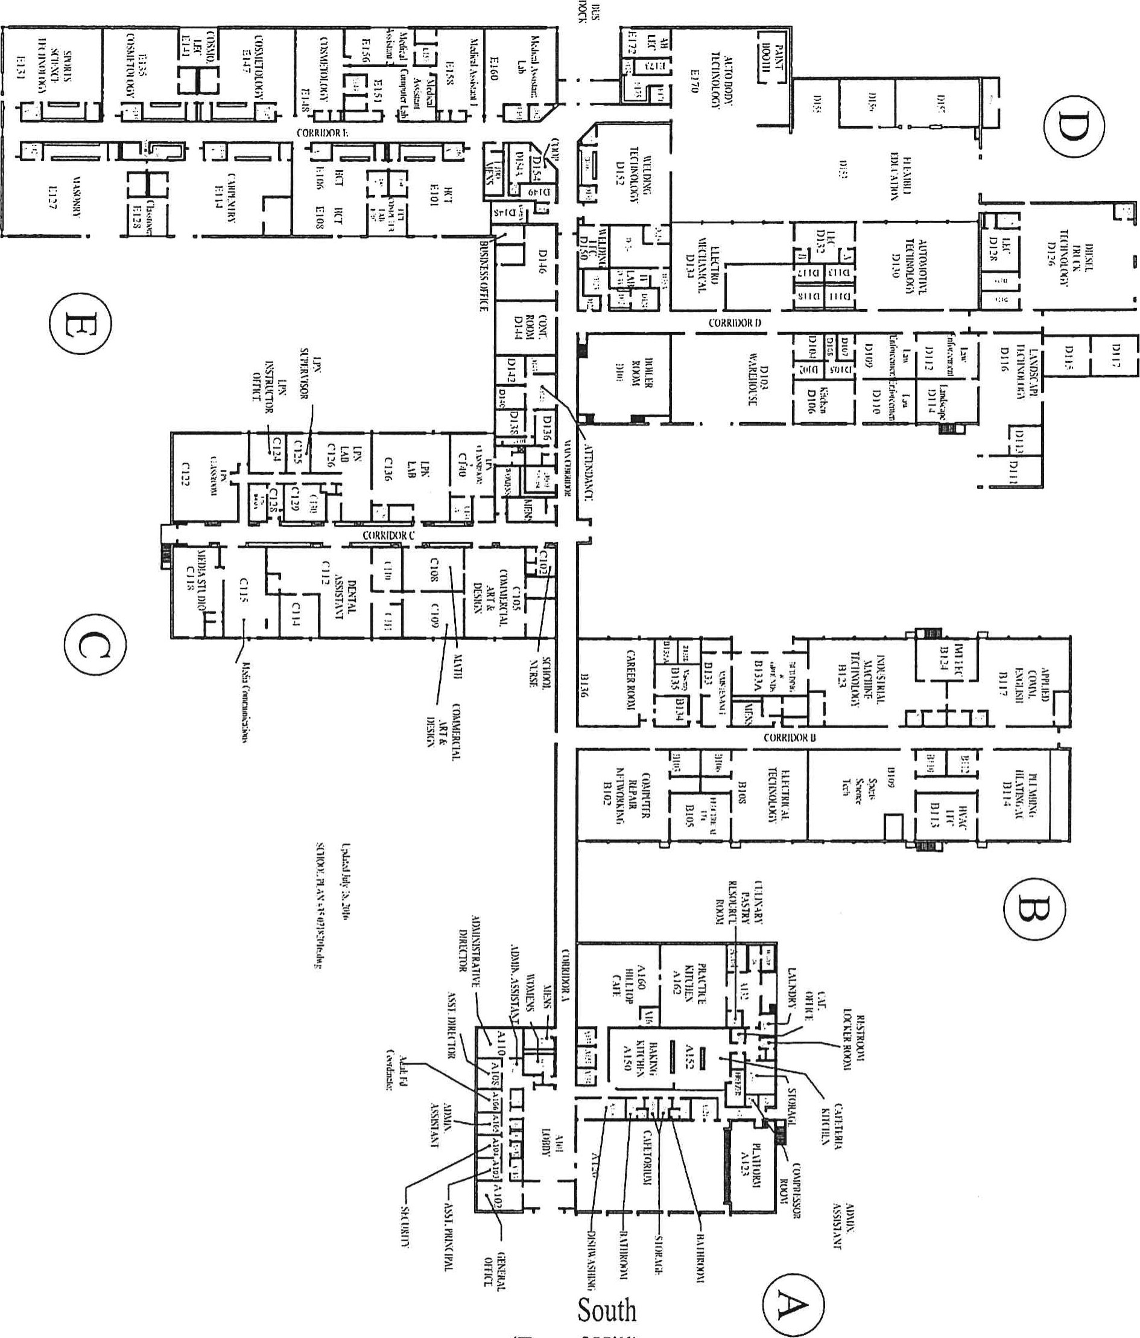
Revised 10/2022

(Top of Hill)

